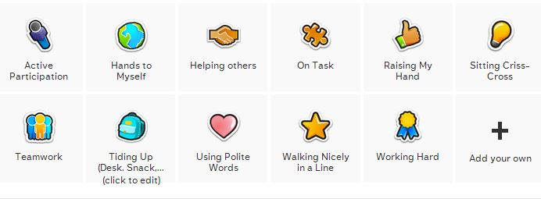
Active Participation: This is awarded when a student participates during class discussions frequently throughout the day. Constantly raising his/her hand to answer a question or contribute to a class discussion. When a student demonstrates that they are engaged with what is going on, either when having a book read out loud to them, or during math “review” time, etc.
Hands to myself: This is awarded once a day for the students who have not received the “Not keeping hands to myself” pin on the “Needs Work” page. This includes not touching other classmates when we walk in line, sit in a circle, or not punching/hitting/pinching others.
Helping Others: These are random acts of kindness that a student can show to another student without being prompted to do so. Example: a student spills water on the floor and another helps to clean it up. These are awarded when such unusual events happen.
On Task: When students are working independently/group and students does not need to be reminded to work on the assignment. This is a student who is seated at his/her desk/ designated area and is completing the assigned task quietly.
Raising my Hand: this is awarded to students who remember to raise their hand and wait to be called on before they give out an answer/share an opinion. This helps to make sure that all students get an opportunity to participate and be heard.
Sitting Criss-cross: this is awarded to students who show appropriate behavior on the carpet during class circle times. Students have their legs crossed, hands in their lap, and body facing the front, and eyes on the teacher. This is awarded also to students who are ready to transition from one activity to another after the teacher has notified students that it’s time by saying “Show me that you are ready…..”..
Teamwork: This is awarded to students who can work collaboratively with a classmate on an assigned task. Both students have to be engaged and equally participating / taking turns. Pairs/groups of students who complete a task/assignment that shows their best collaborative effort.
Tiding Up: This is awarded to students who clean up their desk after snack time (throwing all trash away and putting snack containers back in their cubby). Also, after lunch time to students who have disposed properly of their lunch tray and water cup and have made sure to not leave any trash behind (napkins, or yogurt container). After an activity in the classroom students are awarded this point is they have successfully and orderly put away their materials where they belong (workbooks, notebooks, worksheets, colored pencils).
Using Polite words: This is awarded to students who remember to use polite words with each other and with their teachers without being prompted to do so (please, thank you, sorry, excuse me, etc).
Walking in a Line: This is awarded to students who walk in a straight line, quietly, with their hands by their sides, keeping up with the rest of the line, and looking forward at the teacher.
Working Hard: This is awarded to students who show dedication to their work. Students who try their best, and if they can’t they ask for help. Students who want to finish their task successfully.

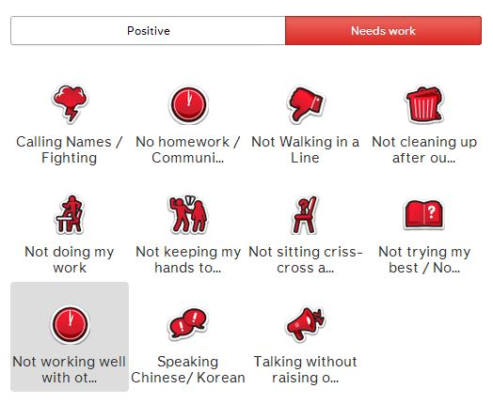
Calling Names/ Fighting: To students who engage in name calling, and /or physically/verbal fighting/arguing with a classmate or teacher.
No Homework/ Communication Book: a student who doesn’t complete their homework or does not bring their communication book to school each day.
Not walking in a line: students who wander off, are touching bulletin boards, are touching the person in front/ behind, are talking/yelling, are jumping or running.
Not cleaning up after myself: students who leave trash on their desk/floor and/or don’t clean up spills. When a student does not put away their materials where they belong. A student who leaves trash at the lunch table and/or water cup/yogurt tray.
Not doing my work: when a student is busy talking with another student, not sitting at his/her desk, working on something that is not the assignment. Walking around the classroom when student should be seated.
Not keeping my hands to myself: when a student touches another student.
Not sitting criss-cross: when a student is not sitting at the carpet/desk and is not listening to the teacher’s instructions/demonstration. A student who is reminded more than once that he/she should be seated (carpet or desk).
Not trying my best: a student who does not try and asks for help without giving their work a try. A student who completes the assignment in a rush and not showing their best effort.
Not working well with others: when a student fights with another over who does what. Or when a student dominates an activity and limits how much the other person can participate in the activity.
Speaking Chinese/Korean: when students speak in Chinese/Korean with their friends/classmates. Students who don’t try to express themselves in English (applicable to those students who have some English vocabulary).
Talking without raising hand: Given to a student who yells out answers without waiting to be called on. A student who gives an answer when it is another student’s turn.

