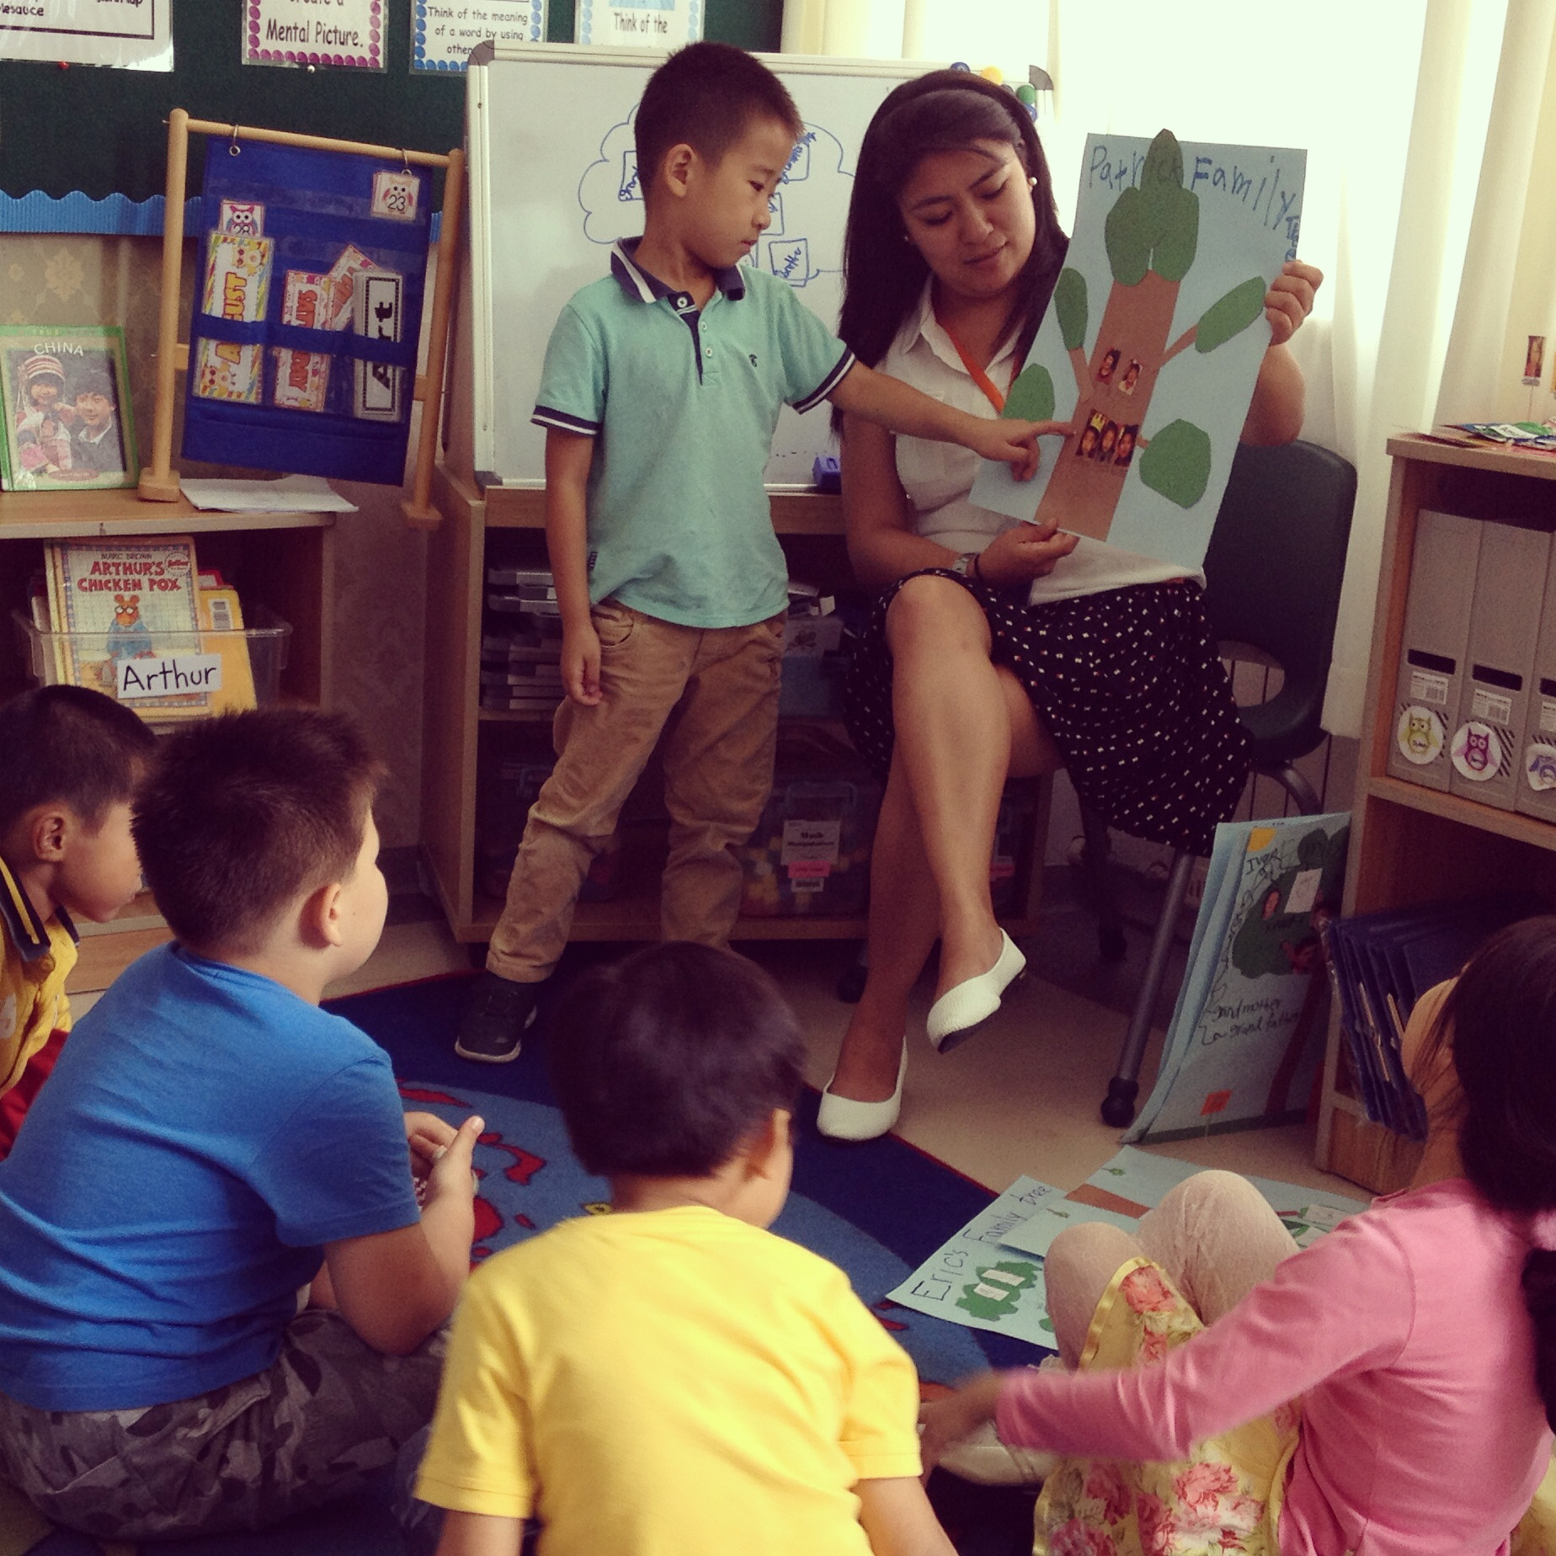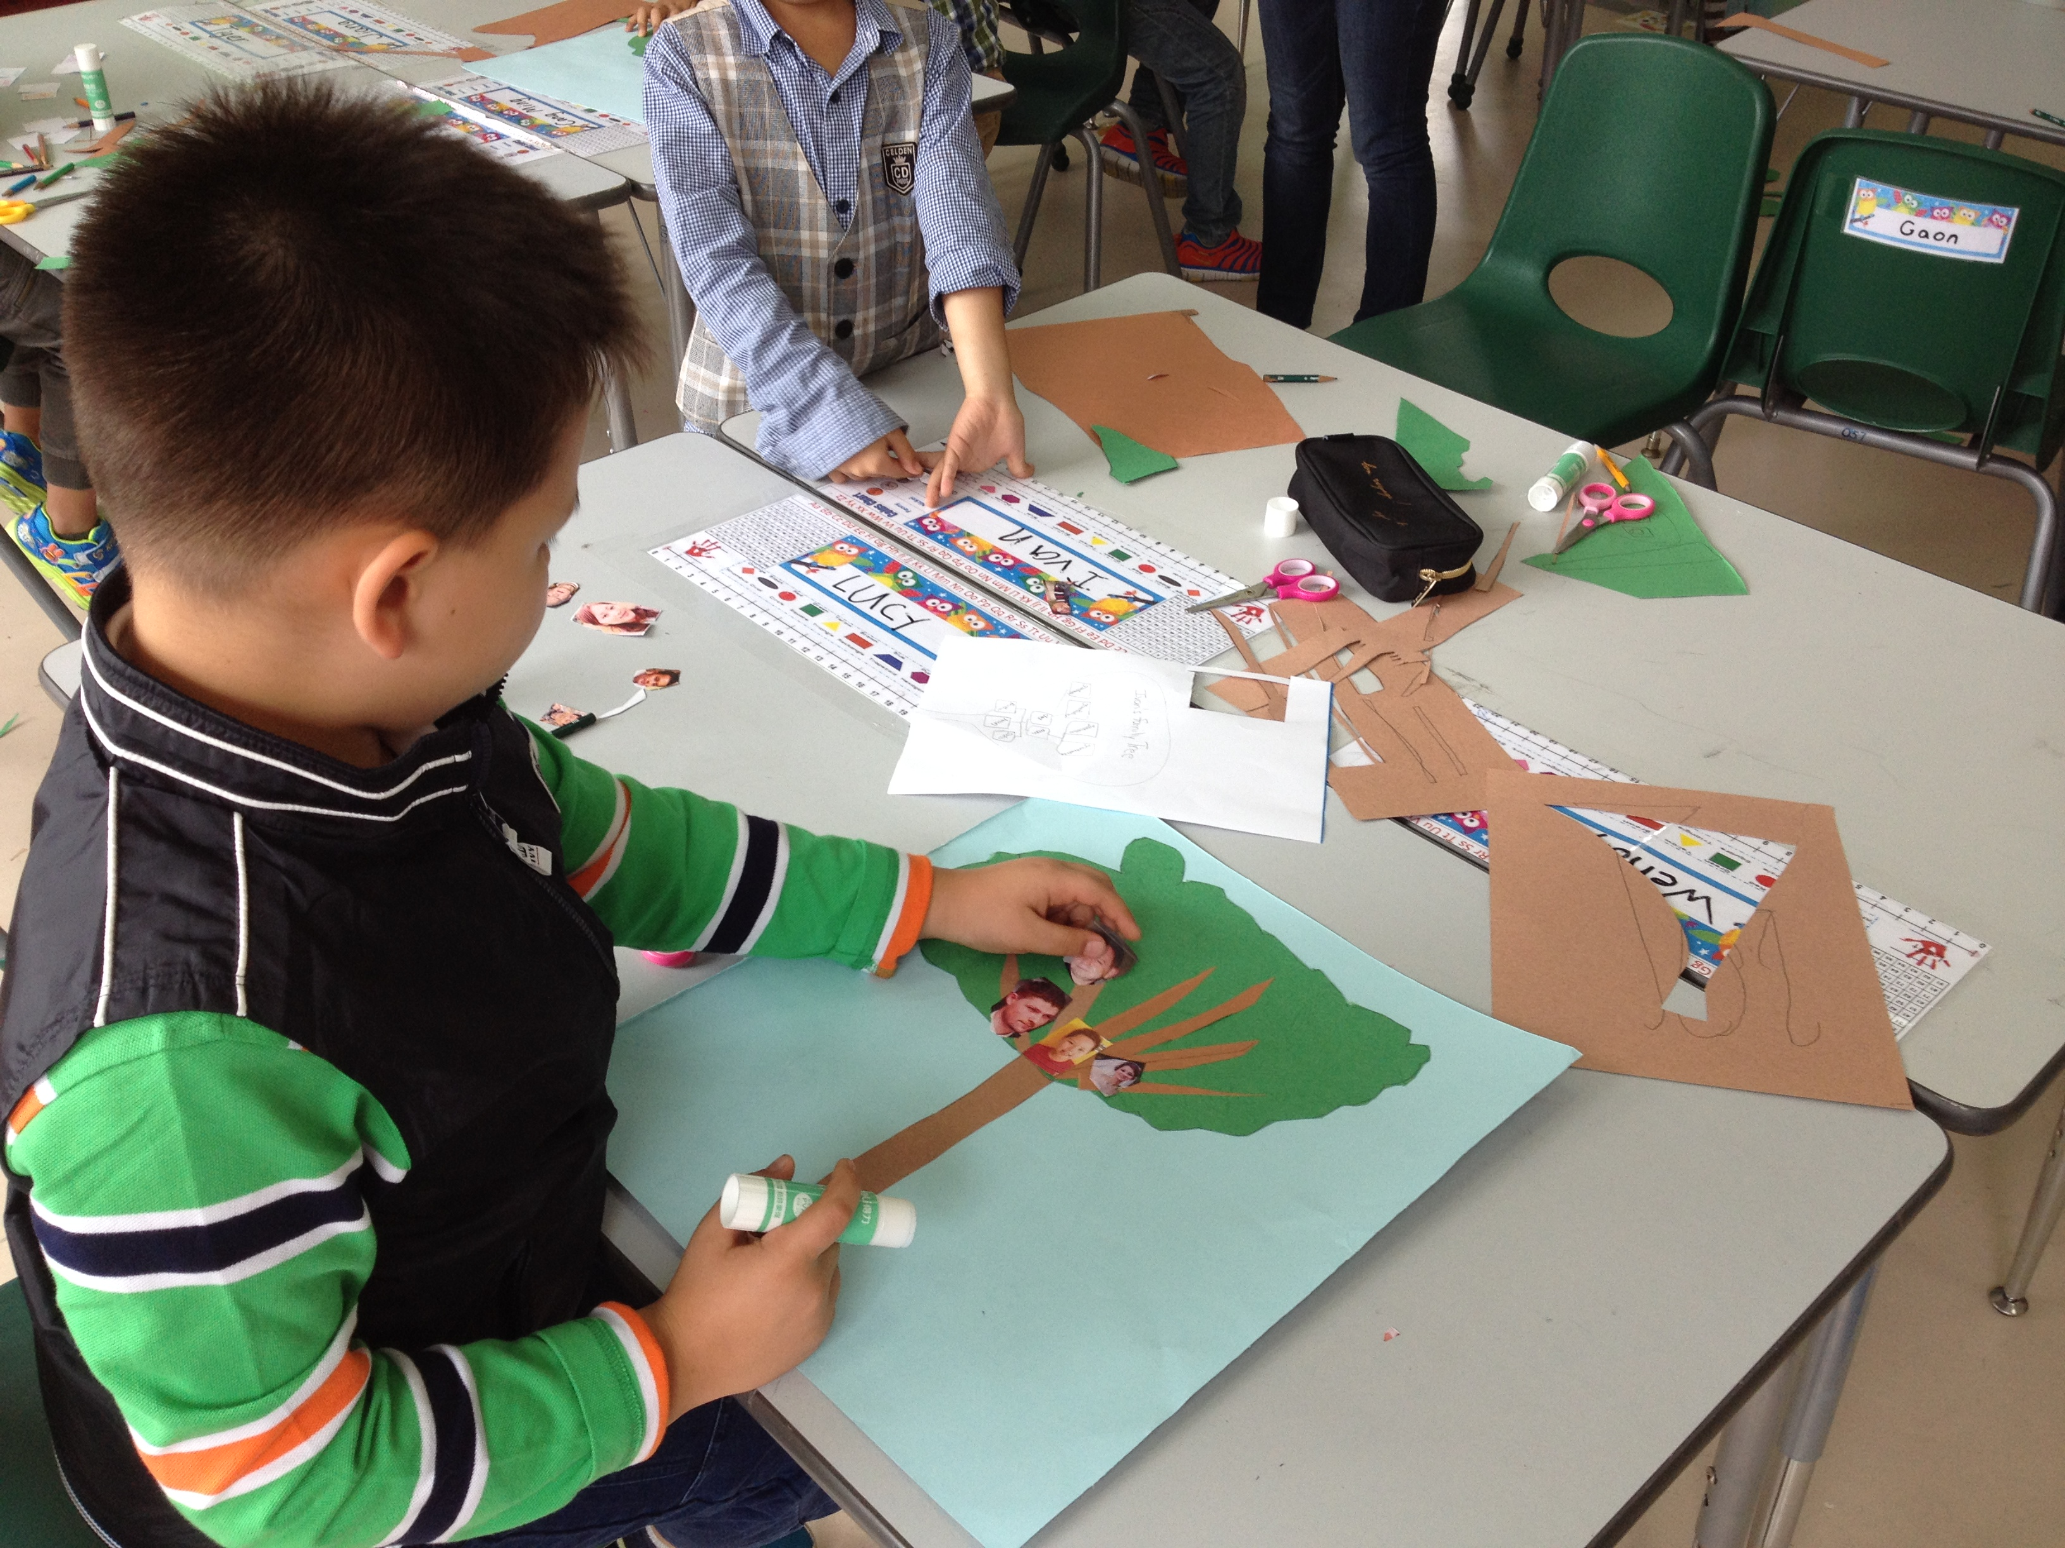

### Homework

Math Journal Pg. 25

Pg. 30

Pg. 33

Pg. 34

Raz-Kids: 20 minutes each day.

###### National Holiday

###### September 29 - October7

Week seven has come and gone so quickly and by now we have dived completely into our unit of inquiry about our families. Students are understanding deeper about their identity as well as the similarities and differences between them and others. Last week students created their own family trees to help them put into perspective where they stand in their family. They practiced saying and writing key terminology about families, and sharing their final pieces with the class. I would like to encourage that you continue to talk with your child about your extended family  (grandparents, uncles, aunts, cousins, etc) so that they make personal connections to what we are learning. Talking about different family members using their first names is also important. If you could help your child learn the names of the members of the immediate family that would be great, as it is common that students only know "This is my mommy" and not mommy's name.

This week we continued working on writing books about "Me" and "Where I am from". Students were able to practice punctuation, grammar and spelling. The books are coming out great and I am looking forward to your child sharing them with you on October 18th during the Key Assignment Day. The week after our break we will be working on making a "Family Crest". Students have started brain storming ideas and designs. The idea of the family crest is that students choose 4-6 symbols that represent their families. You can help your child at home by discussing what your family likes to do together, or things that represent your family specifically. These family crests will also be presented on Key Assignment day.

In Math we are continuing with coin addition and soon will be starting coin subtraction. By now most students can recognize coins and its respective value. We are also starting to look at odd and even numbers. Please ask your child to share with you how they can identify is a number is odd or even.

Have a GREAT break!

Kind Regards, Ms. Melissa

# “Me and My Family”

September 26, 2014

Ms. Melissa

* Grade 1 Newsletter

Nunc cursus magna quis

Donec varius, felis eget lobortis vehicula, magna sapien elementum tellus, ut iaculis dui orci sed arcu. Nullam semper leo.

Consectetuer adipiscing elit. Suspendisse hendrerit ligula eget odio. Sed erat nisi, rhoncus id, imperdiet quis, blandit et, felis. In at nulla mattis neque commodo venenatis. Cras ultrices tincidunt risus. Quisque dictum diam adipiscing arcu. Proin enim. In diam turpis, suscipit fringilla, dapibus quis, dictum ut, ipsum. Phasellus id elit in dui bibendum bibendum.

Praesent vitae nisl.